

College: Engineering and Information
Technology Department: Information Technology
(Data Analytics)
Program: Probability theory and its applications
Project Title: Diabetes

Supervised By: Dr. Huseyin Kusetogullari
Team members
1. Hayatt Al-Abed 202410038
2. Asmaa Alsaloum 202410458

Academic Year 2025- 2026 – Fall Semester
1. Introduction
Probability theory is the basis of statistical inference and decision-making in conditions of uncertainty. In health data analytics, this discipline underpins techniques for modeling the variability in biological attributes, quantifying risk, and making inferences from small samples. Randomness in patient measurements such as height, weight, and cholesterol can be modeled as random variables, and probability distributions can be used to describe their behavior.
This project applies probability theory and statistics to a real health-related dataset. The dataset contains patient attributes including Gender, Height, Weight, Cholesterol level, and Diabetes status. Using this data, we study empirical distributions, compute statistical moments, investigate relationships among variables, and build probabilistic models to predict diabetes.
Objectives of this project are to:
- Explore the dataset and clean it. Understand the structure of it.
- Describing data distributions using histograms, PMFs, and CDFs.
- Compute and interpret the following statistical moments: mean, variance, skewness, and kurtosis.
- Relate pairs of variables using covariance and correlation, including by gender
- Model linear relationships using regression (Weight from Height and Diabetes from Cholesterol).
- Applying the Naïve Bayes classification model to predict diabetes from multiple features.
- Connecting each analytical step back to probability theory concepts such as random variables, distributions, conditional probability, and independence.

2. Dataset Description
The dataset is stored in an Excel file named Data.xlsx and contains 4000 rows and 5 columns. Each row represents a different patient.
The variables are:
Column | Symbol | Description | Type
Gender | Gender | Gender (M/F → 1/0 after encoding) | Categorical → Numeric
Height | Height | Height in centimeters | Numeric (float)
Weight | Weight | Weight in kilograms | Numeric (float)
Chol. | Cholesterol | Cholesterol level (mg/dL) | Numeric (float)
Diab. | Diabetes | Diabetes status (0 = No, 1 = Yes) | Binary (int)
After loading the dataset, we inspected its structure using df.info (). We found:
- 3 float64 columns: Height, Weight, Cholesterol
- 1 int64 column: Diabetes
- 1 object column: Gender
- No missing values and no duplicate rows.
This confirmed that the dataset was complete and did not require imputation.
2.1 Outlier Detection and Handling
Boxplots for Height, Weight, and Cholesterol were created to visually inspect extreme values. The boxplots showed that:
- Height had a relatively narrow spread, with only a few mild outliers above 200 cm.
- Weight had a wider interquartile range and more outliers at high weights.
- Cholesterol had the biggest spread with many high outliers above 300 mg/dL.
- Since extreme values of cholesterol can be highly influential for variance and skewness, we resorted to IQR-based clipping. For every numeric column - Height, Weight, Cholesterol, we computed:
- Q1 (25th percentile), Q3 (75th percentile),
- IQR = Q3 − Q1,
- Lower limit = Q1 − 1.5 × IQR,
- Upper limit = Q3 + 1.5 × IQR.
Values outside this range were clipped to the corresponding limit. After clipping, residual outliers were effectively removed while keeping the overall structure of the distributions.
2.2 Label Encoding
The Gender column (M/F) was converted to numeric values using label encoding:
- Female = 0
- Male = 1
This encoding allows Gender to be used in mathematical formulas and machine learning models

3. Methodology
This section describes the analytical steps and links them directly to probability theory.
3.1 Descriptive Statistics
We calculated descriptive statistics - mean, min, max, standard deviation, and quartiles - of Height, Weight, and Cholesterol. The results were approximately:
- Average Height ≈ 168.85 cm
- Average Weight ≈ 74.99 kg
- Average Cholesterol ≈ 205 mg/dL
These provide the expected value and spread for each of the random variables.
3.2 Probability Mass Function (PMF)
In each case, we generated empirical PMFs by first binning each numeric variable (Cholesterol, Weight, Height) into intervals and then normalize the counts so that the total probability sums to 1. Histograms were plotted before and after normalization:
- Before normalization: bar heights represent frequencies.
- After normalization: bar heights represent probabilities, and the area under each histogram ≈ 1.0.
All three variables show roughly bell-shaped distributions, which is common for human biological measurements.
3.3 Cumulative Distribution Function (CDF)
CDFs of Height, Weight, and Cholesterol. Each of the following CDFs shows the probability that the variable takes a value less than or equal to x. Each of these CDFs is a smooth S-shaped curve that starts near 0 and approaches 1 smoothly, suggesting continuous and approximately symmetric distributions.
3.4 Effect of Bin Size
To study how discretization influences the PMF shape, we varied the number of bins for each variable, considering 8, 20, and 50.
- Fewer bins → smoother but less detailed shape.
- More bins → more detailed but slightly noisier shape.
Despite changing the numbers of bins, the general distributions remained Gaussian-like, showing that the underlying patterns are stable and not sensitive to the choice of binning.
3.5 Statistical Moments
We computed the four significant moments for Cholesterol (C), Weight(W) and Height(H):
Variable | Mean | Variance | Skewness | Kurtosis
C | 204.95 | 1265.30 | 0.159 | −0.112
W | 74.96 | 213.60 | 0.166 | −0.226
H | 168.84 | 98.94 | −0.025 | −0.131
- Skewness close to 0 says near-symmetry.
- Slight negative kurtosis indicates light tails, few extreme outliers after clipping.
These values quantify the shape characteristics of each probability distribution.
3.6 Gaussian Curve Fitting
We further tested normality by overlaying the histograms with Gaussian (Normal) curves that possess the same mean and standard deviation as empirical data. In all three variables, Height, Weight, Cholesterol, the red normal curves fitted the histograms very well. This confirms that all three variables can be approximated with normal distributions.
3.7 Covariance and Correlation
We computed covariance and Pearson correlation for all pairs of (Cholesterol, Weight, Height). The results showed:
- Cholesterol & Weight: r ≈ 0.16 (weak positive)
- Cholesterol & Height: r ≈ −0.04 (negligible negative)
- Weight & Height: r ≈ −0.05 (negligible negative)
All correlation coefficients are small in magnitude, suggesting very weak linear relationships among these variables. This implies that, in this dataset, cholesterol, weight, and height are nearly independent in terms of linear dependence.
3.8 Gender-Based Analysis
To investigate whether gender affects distributions or relationships, we repeated the PMF, CDF, Gaussian fit, and correlation analysis separately for:
- Females (Gender = 0)
- Males (Gender = 1)
For both groups, the variables Cholesterol, Weight, Height were approximately normally distributed.
- In females, the relationship between cholesterol and weight was r ≈ 0.17, which is still weak.
- In men, the correlation was similarly low: r ≈ 0.15.
Overall, gender did not substantially alter the relationships among variables, and distributions remained bell-shaped in each subgroup.
3.9 Linear Regression: Predicting Weight from Height
We have performed a simple linear regression to predict Weight from Height:
- Data split: 80% training, 20% testing.
- Regression equation (from the dataset):
WfH = 88.432 − 0.080 × H
- Correlation coefficient between actual W and predicted WfH: r ≈ 0.0543.
This very low correlation indicates that, in this dataset, height is not a useful linear predictor of weight. The regression line is almost horizontal.
3.10 Linear Regression: Predicting Diabetes from Cholesterol
We also fitted a linear regression model to predict Diabetes from Cholesterol, treating Diabetes as a continuous variable between 0 and 1 in order to see the trend:
Equation:
DfC = −0.7762 + 0.0062 × C
Correlation between D and DfC: r ≈ 0.45, indicating moderate positive association. Higher levels of cholesterol are related to a higher possibility of diabetes. Although linear regression is not ideal for binary outcomes, it is useful here for visualizing the probabilistic relationship: DfC values close to 1 suggest higher risk.

3.11 Naïve Bayes Classification for Diabetes Prediction
Finally, we applied a Gaussian Naïve Bayes classifier to predict Diabetes using:
- Gender
- Height
- Weight
- Cholesterol
- The dataset was again split into 80% training and 20% testing. Naïve Bayes assumes conditional independence of features given the class and uses probability density functions to model continuous attributes.

4. Results and Analysis
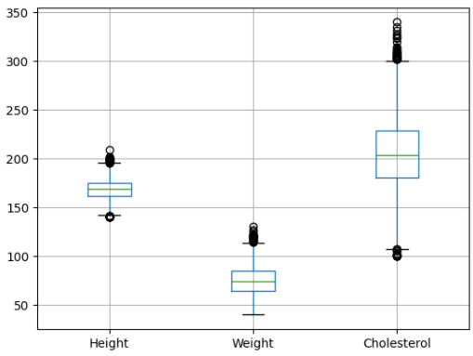
Figure 1. Histograms of Height, Weight, and Cholesterol (Before Outlier Handling)
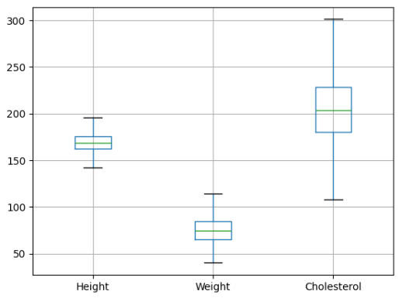
Figure 2. Boxplots of Height, Weight, and Cholesterol (Outlier Detection)
Figure 3. PMFs for Height, Weight, and Cholesterol (Normalized)
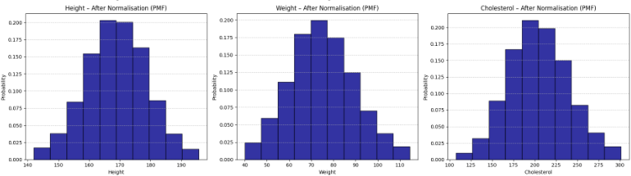
Figure 4. Histogram, PMF’s and CDFs of Height, Weight, and Cholesterol
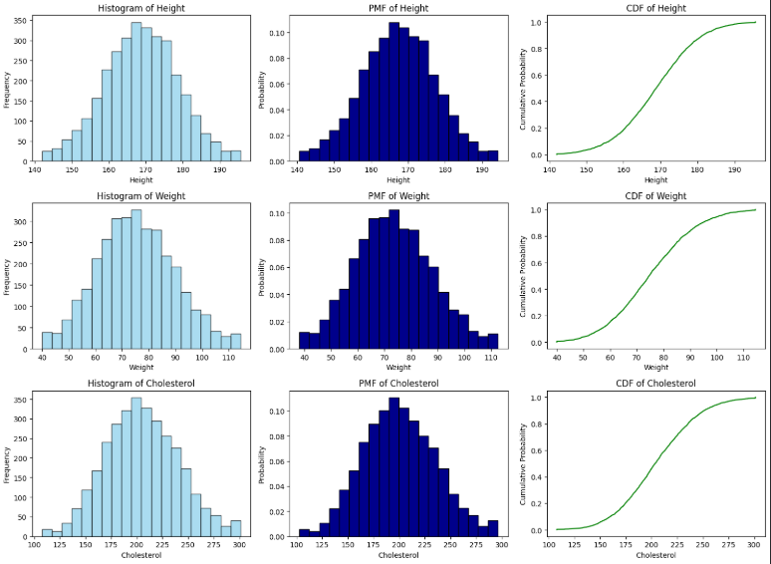

Figure 5. Effect of Bin Size (8, 20, 50 bins) on PMFs
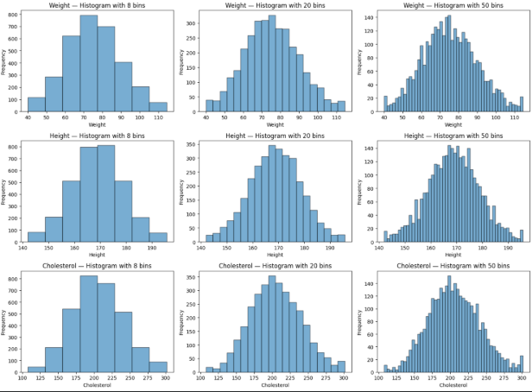
Figure 6. Gaussian Curves overlaid on Histograms
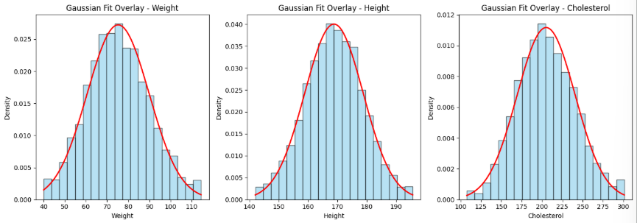

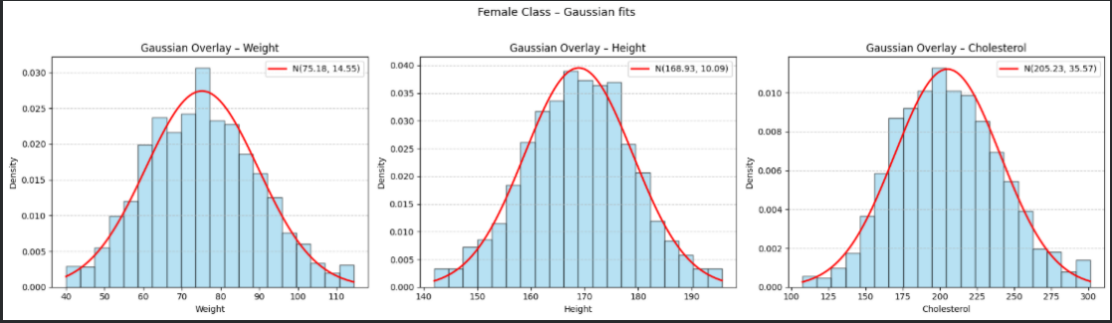
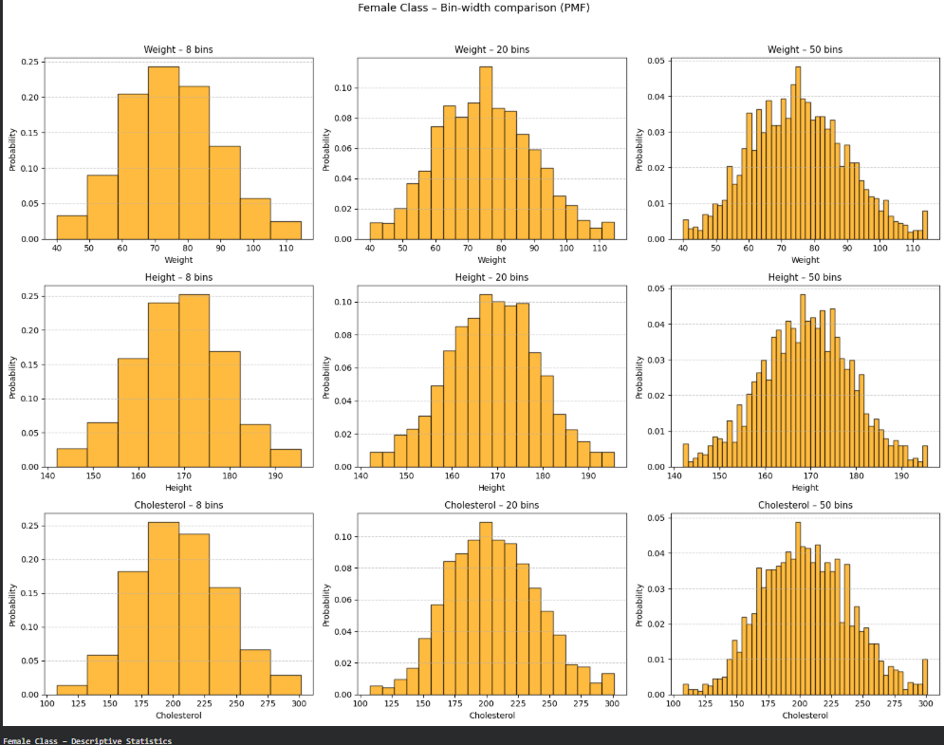
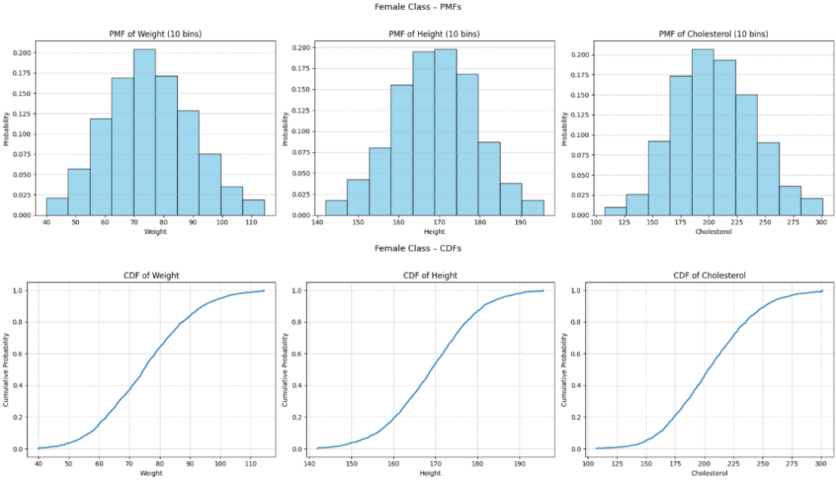
Figure 7. Gender-Separated PMFs and CDFs
Female:
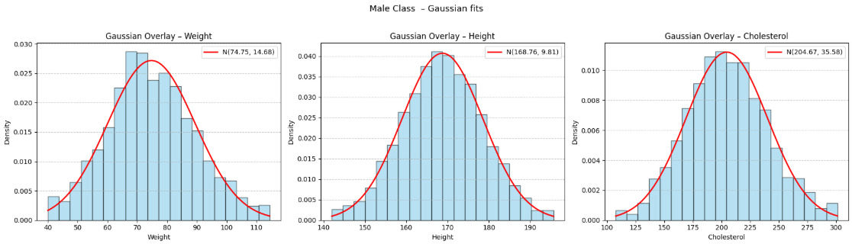
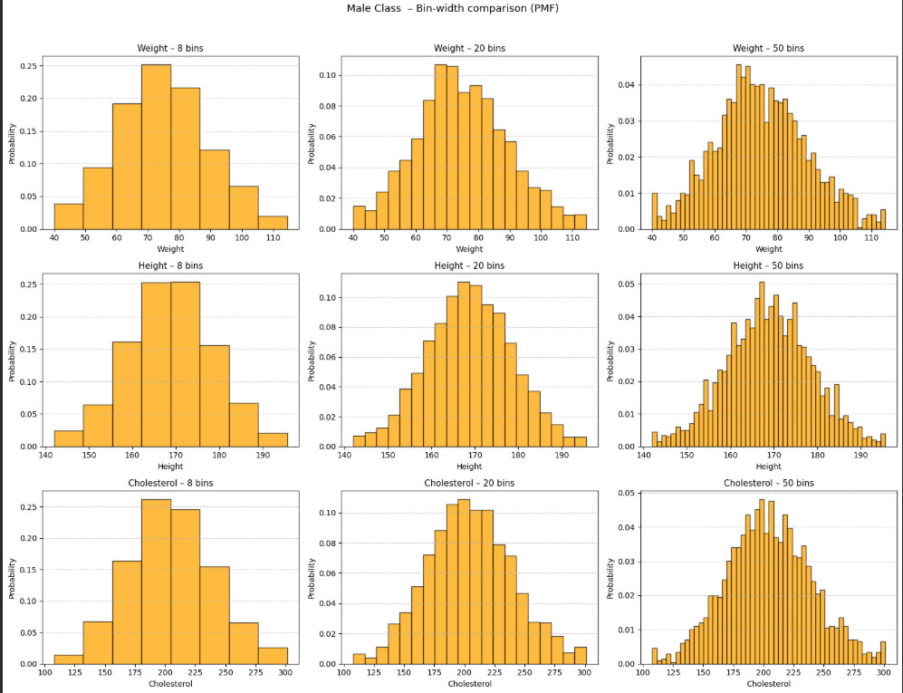
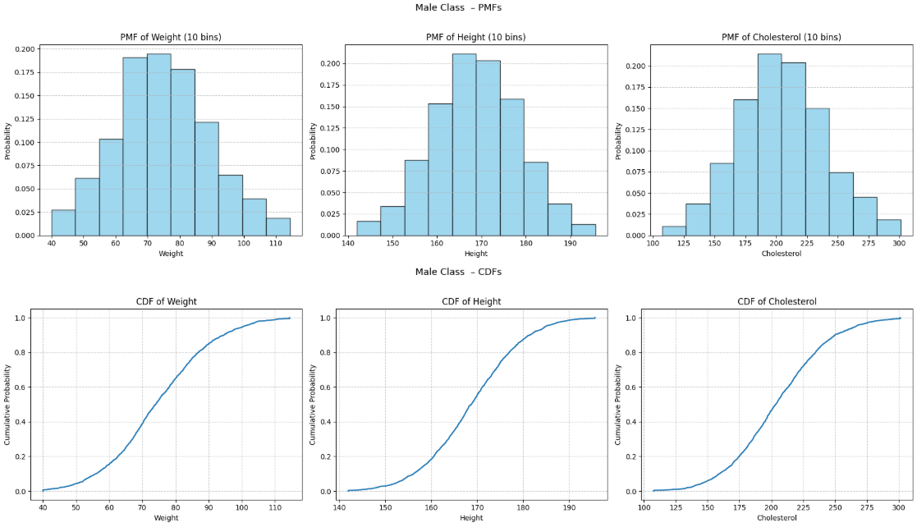
Male:
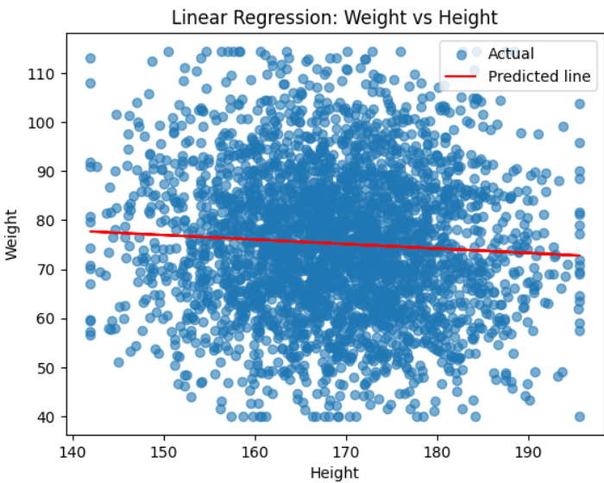
Figure 8. Scatterplot and Regression Line: Weight ~ Height

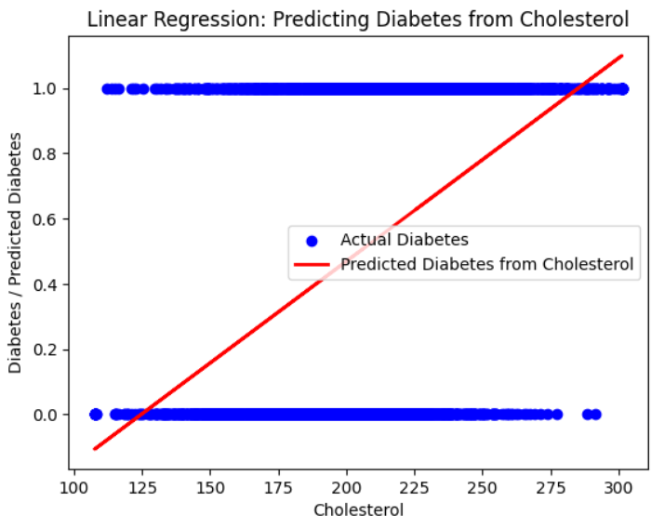
Figure 9. Scatterplot and Regression Line: Diabetes ~ Cholesterol

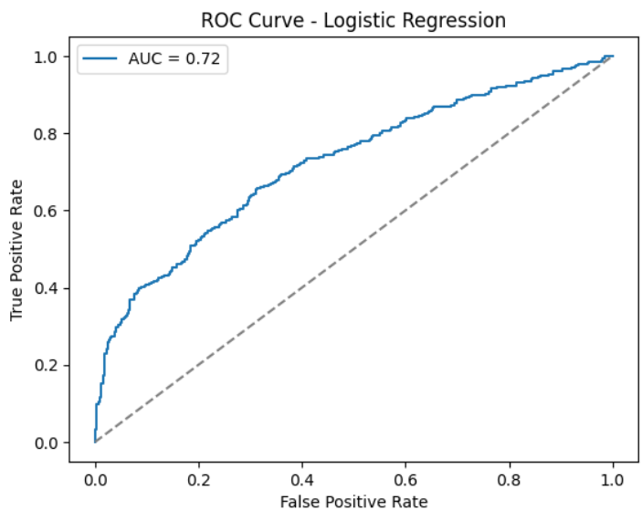
Firgure10. Logistic Regression – Diabetes

Figure 11. Naïve Bayes Confusion Matrix and Performance Metrics
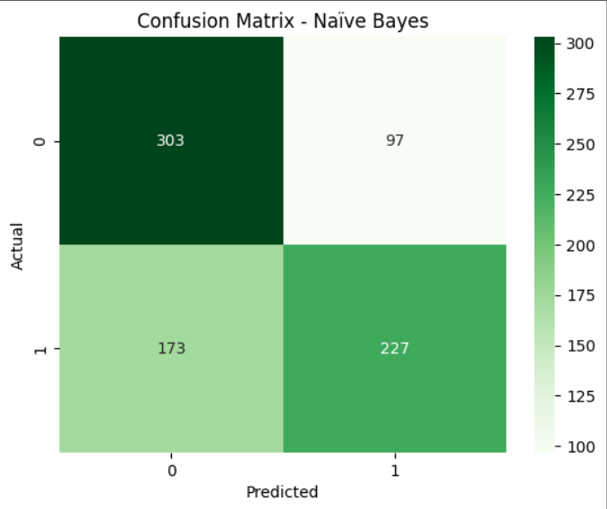

4.1 Summary of Statistical and Model Metrics
Metric | Value (from Colab) | Interpretation
Mean Height | ≈ 168.85 | Average height
Mean Weight | ≈ 74.99 | Average weight
Mean Cholesterol | ≈ 205 | Average cholesterol
Corr(Cholesterol, Weight) | ≈ 0.16 | Weak positive relationship
Corr(Cholesterol, Height) | ≈ −0.04 | Negligible linear relationship
Corr(Weight, Height) | ≈ −0.05 | Negligible linear relationship
Corr(Weight, WfH) | ≈ 0.054 | Height is a poor predictor of Weight
Corr(Diabetes, DfC) | ≈ 0.45 | Moderate relationship between Cholesterol and Diabetes
Naïve Bayes Accuracy | ≈ 74.38% | Correctly classified diabetes outcomes
Precision / Recall / F1 (Naïve Bayes) | ≈ 0.74 each | Balanced classification performance

Naïve Bayes confusion matrix (from Colab):
- True Negatives: 336
- False Positives: 86
- False Negatives: 119
- True Positives: 259

5. Discussion
The analysis shows how core probability concepts can be applied to real health data:
- PMF and CDF: Convert the raw counts to probability models that indicate the probability of various ranges of height, weight, and cholesterol.
- Statistical moments: The mean and variance are measures for the expected value and dispersion, respectively, while skewness and kurtosis are measures of symmetry and tail behavior.
- Gaussian fitting: verifies that human height, weight and cholesterol can be well modeled by normal random variables after handling of outliers.
- Covariance and correlation: Reveal that these variables are mostly independent in terms of linear relationships, with only a weak relationship between cholesterol and weight.
- Gender-based analysis: Demonstrates conditional probability P(X|Gender); the fact that distributions are similar for males and females suggests stable patterns across the population.
- Regression models:
  - The regression of Weight ~ Height has close to zero predictive power, showing that not all the variables are linearly related, even if they might be conceptually related.
- the regression Diabetes ~ Cholesterol is of a moderate positive slope; hence, probability of diabetes increases with cholesterol.
- Naïve Bayes classifier: probabilistic classification making use of Bayes' theorem and independence assumptions to estimate P(Diabetes=1 | Gender, Height, Weight, Cholesterol).Its ≈ 74% accuracy shows that the status of having diabetes can be meaningfully predicted by a simple probability-based model.
Taken together, these results underscore the point that probability theory is not abstract but directly supports data analysis and decision-making within healthcare settings.

6. Limitations
- Although this is a sizable dataset, it is nevertheless a simulated/limited population, and its generalization to all demographics is not warranted.
- Only a small set of predictors was used: Gender, Height, Weight, Cholesterol; important factors that might describe the variation include things like age, exercise, diet, genetics, and blood sugar level.
- Although variables appear approximately normal, some deviations from perfect normality may affect Gaussian-based models.
- Linear regression is not ideal for modeling a binary variable like diabetes; logistic regression or probit models could also be used.
- The Naïve Bayes assumes conditional independence of features given the class, which in reality might not be perfectly true.

7. Conclusion
This project applies the theory of probability and statistics to health data analysis with an aim to forecast disease outcomes.
Key findings include:

- Height, weight, and cholesterol in the dataset are approximately normally distributed after outlier handling.
- The correlations among these variables tend to be weak; cholesterol has the strongest relationship with diabetes, though still moderate.
- Although the linear regression of weight upon height is unreliable in order to predict weight by height, the trend of cholesterol and diabetes risk is meaningful.
- Diabetes can be predicted based on gender, height, weight, and cholesterol using a Naïve Bayes classifier that reaches an accuracy of about 74% in illustrating the support of decision by probabilistic models for healthcare.
Overall, the project ties together descriptive statistics, probability distributions, regression, and probabilistic classification into a coherent analysis, thus linking theoretical probability to practical health analytics.

